**Banking Application Source Code**

I have used Spring boot, JPA and Angular . Please see the screen shot.

1. Login page

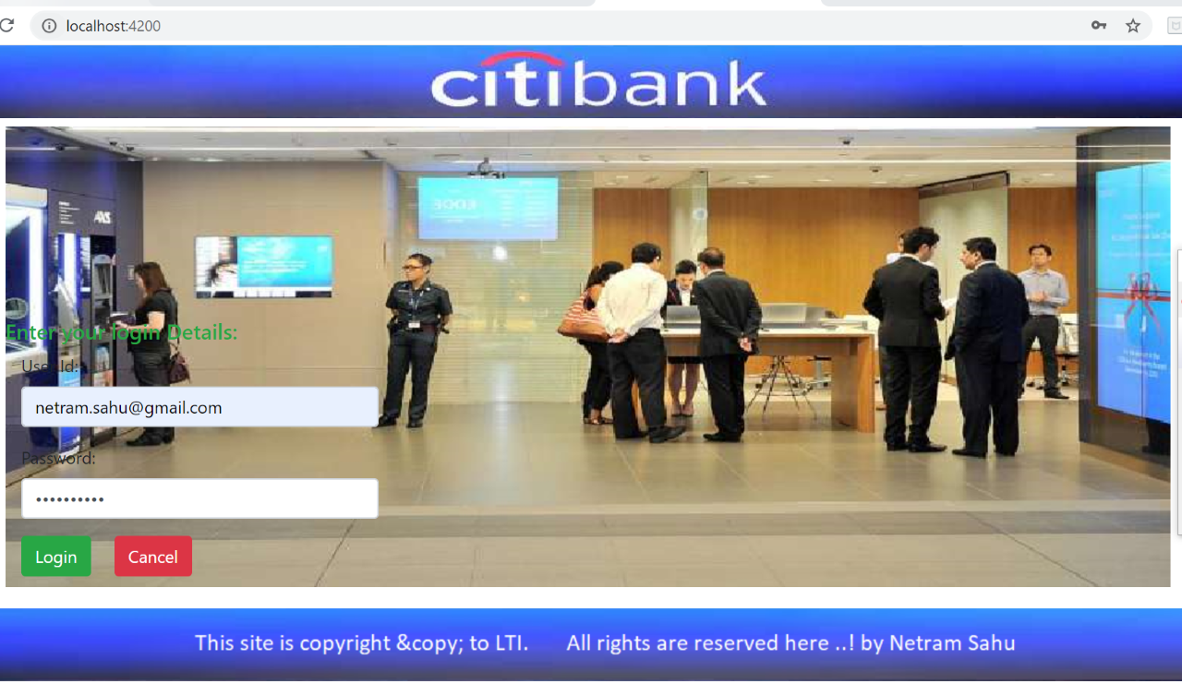

2. Add new Customer

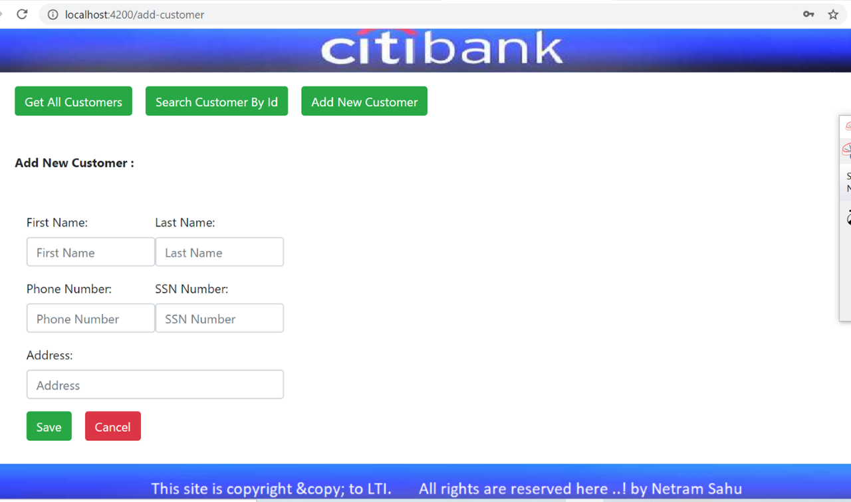

3. Customer Validation

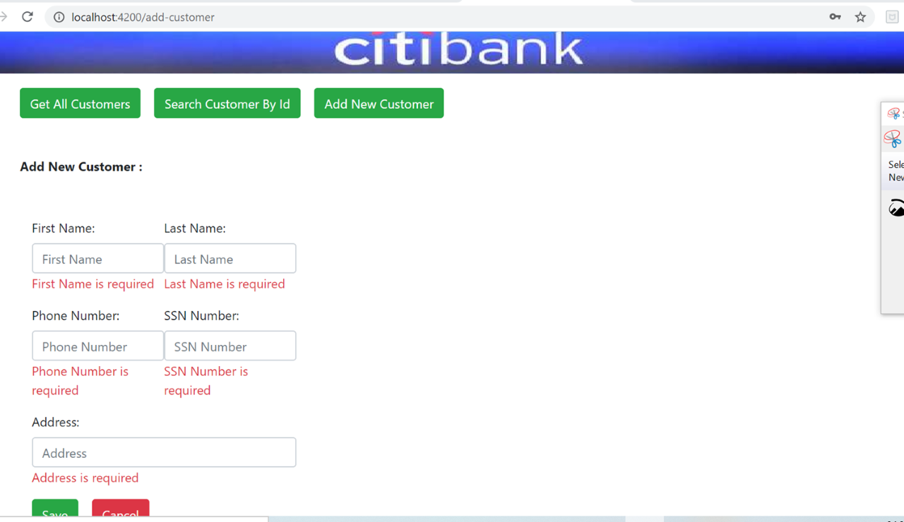

4. Submit Customer Details

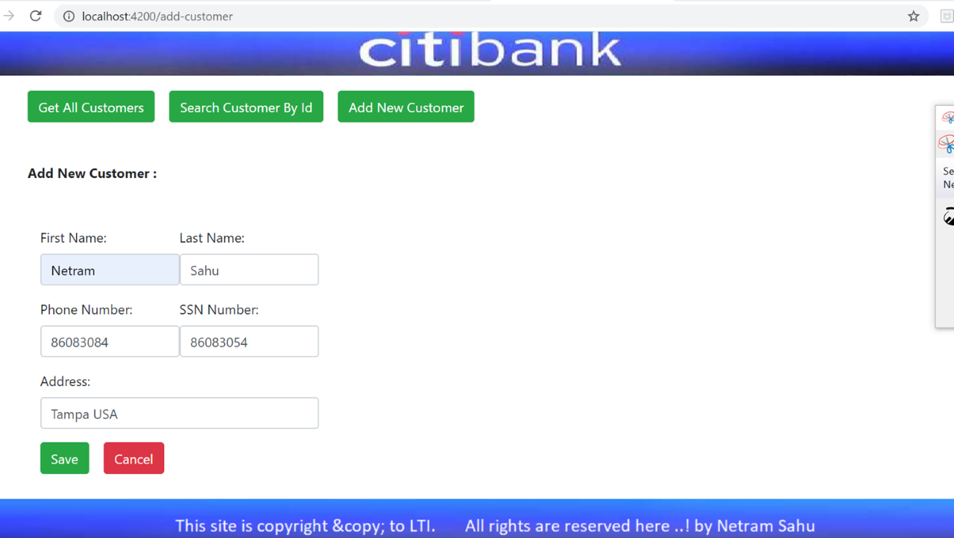

5. Save and Fetch all Customer Records

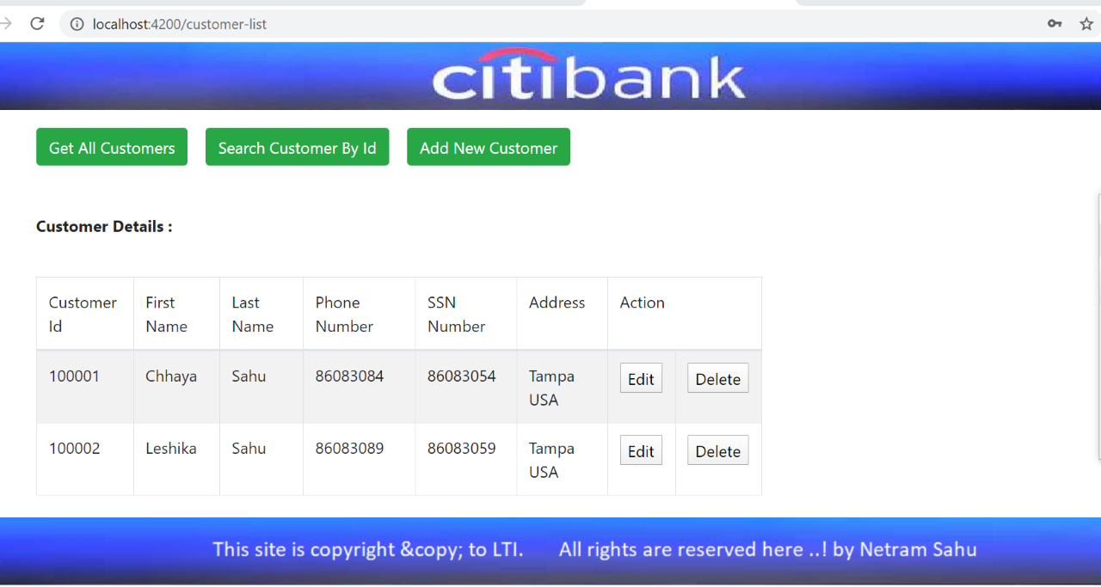

6. Update Customer records

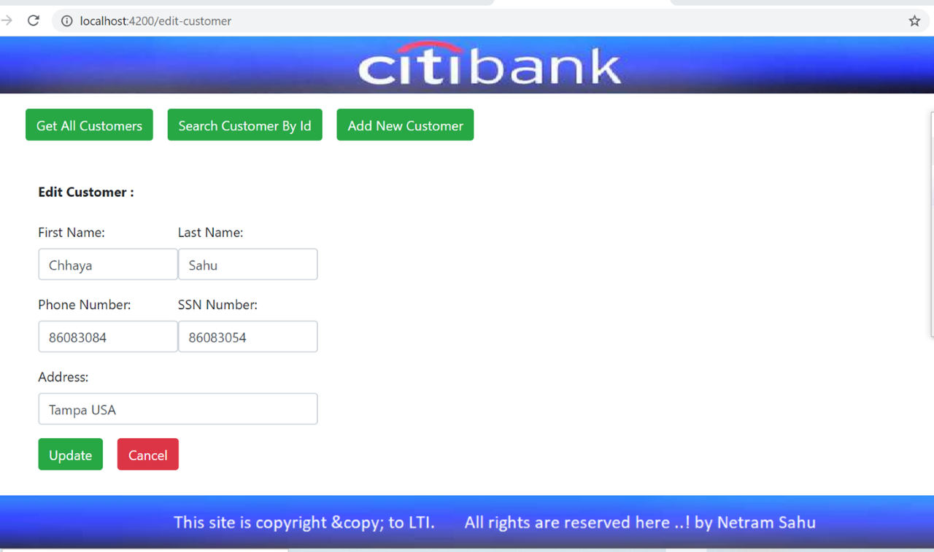

7. Delete Customer records.

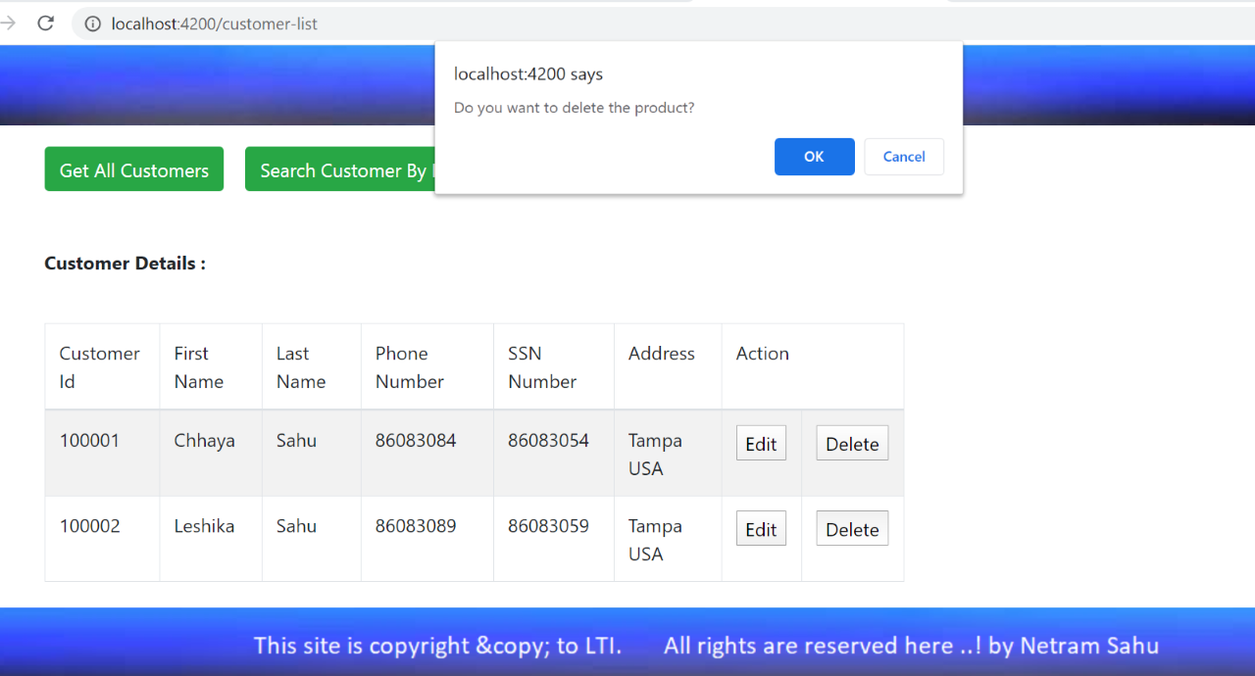

8. After delete fetch remaining records.

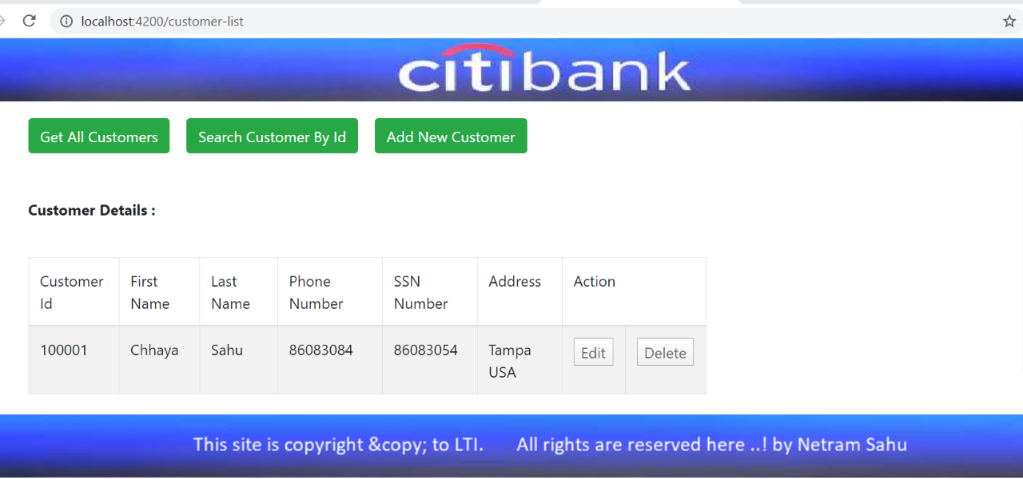

**Entity class with** [**lombok**](eclipse-javadoc:%E2%98%82=TestLombok/C:%5C/Users%5C/Lenovo%5C/.m2%5C/repository%5C/org%5C/projectlombok%5C/lombok%5C/1.18.4%5C/lombok-1.18.4.jar%3Clombok) **@ Data**

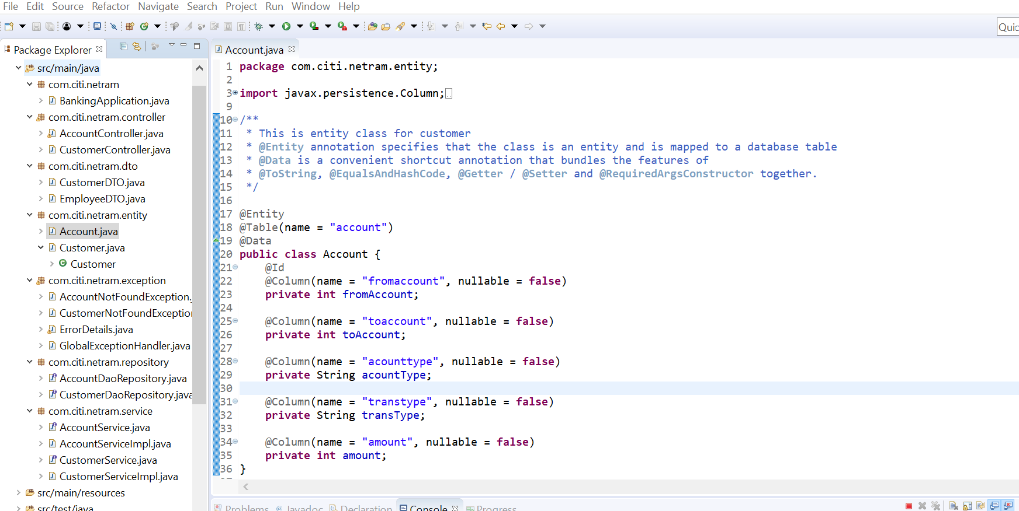

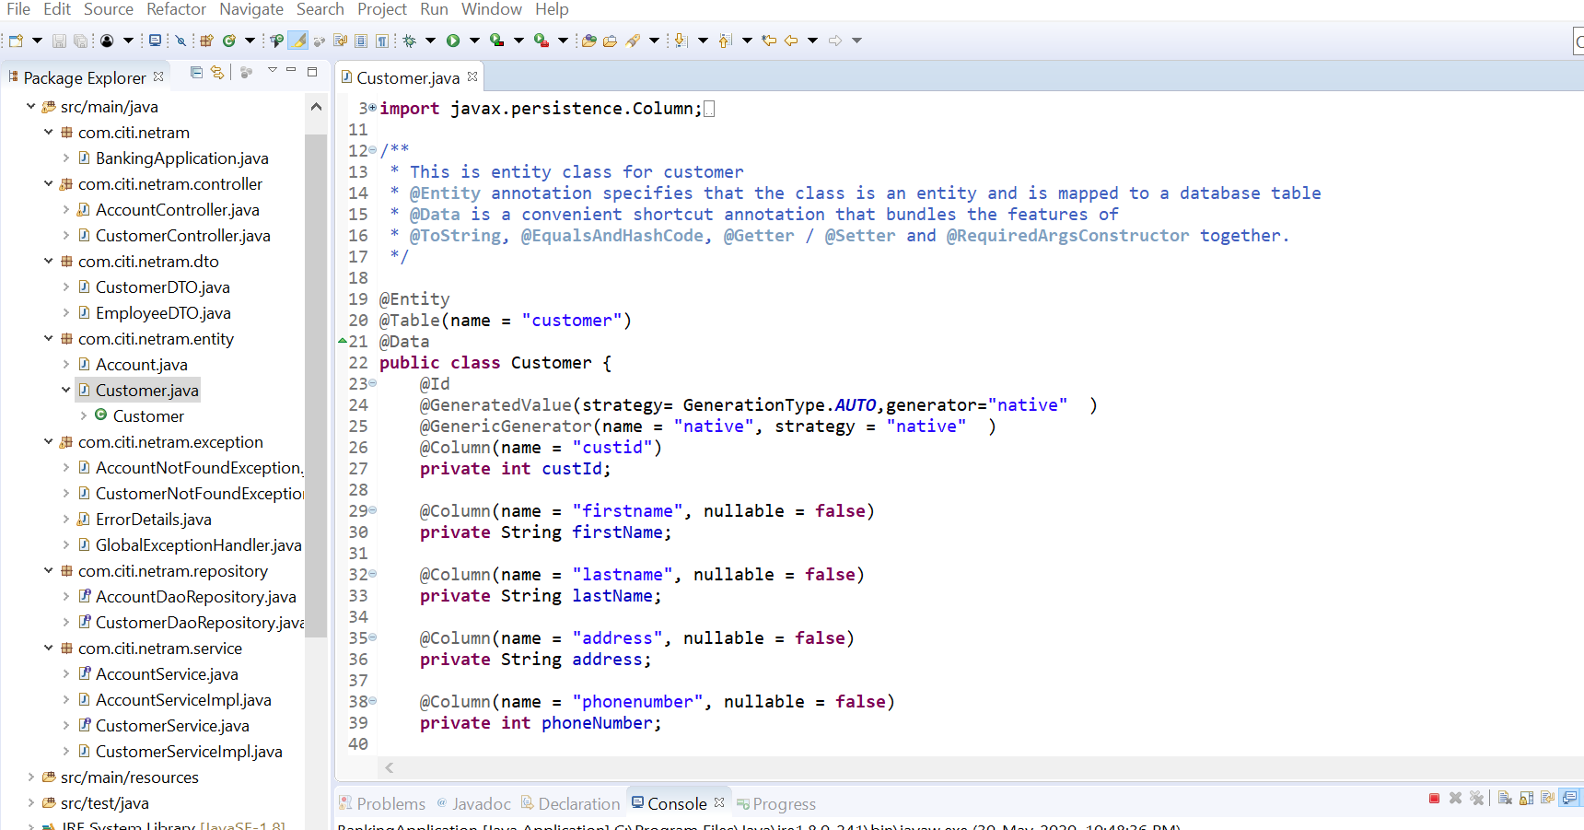

**Main controller class**

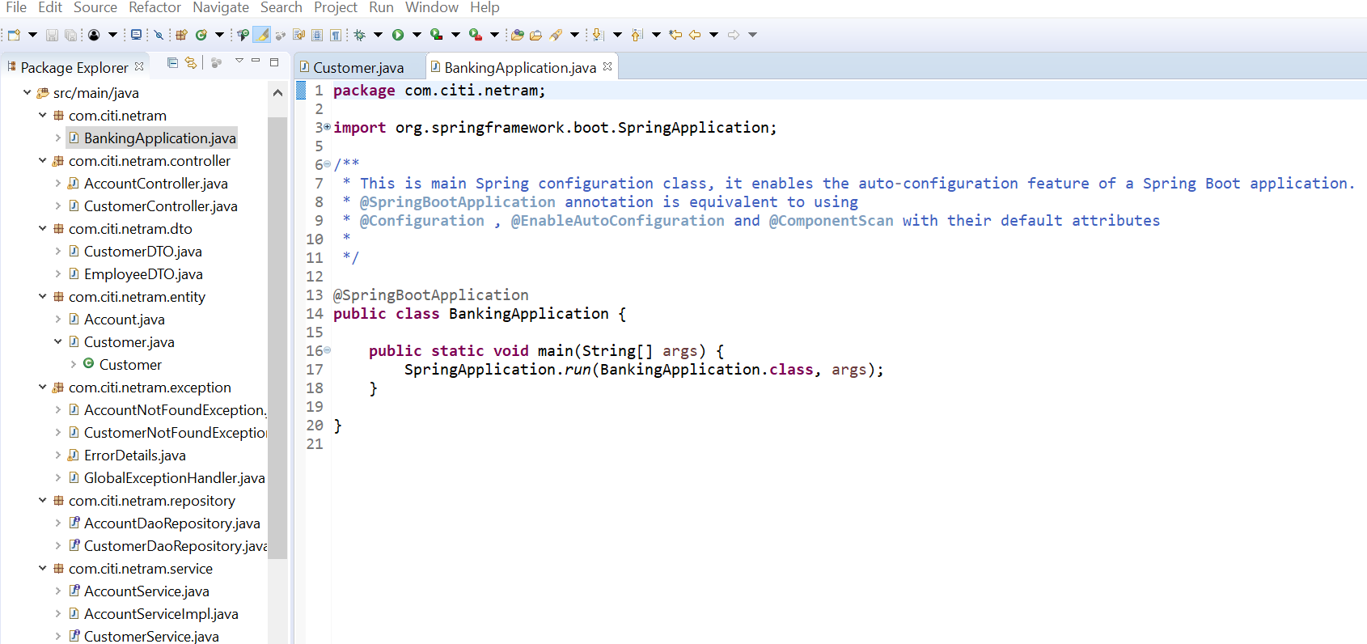

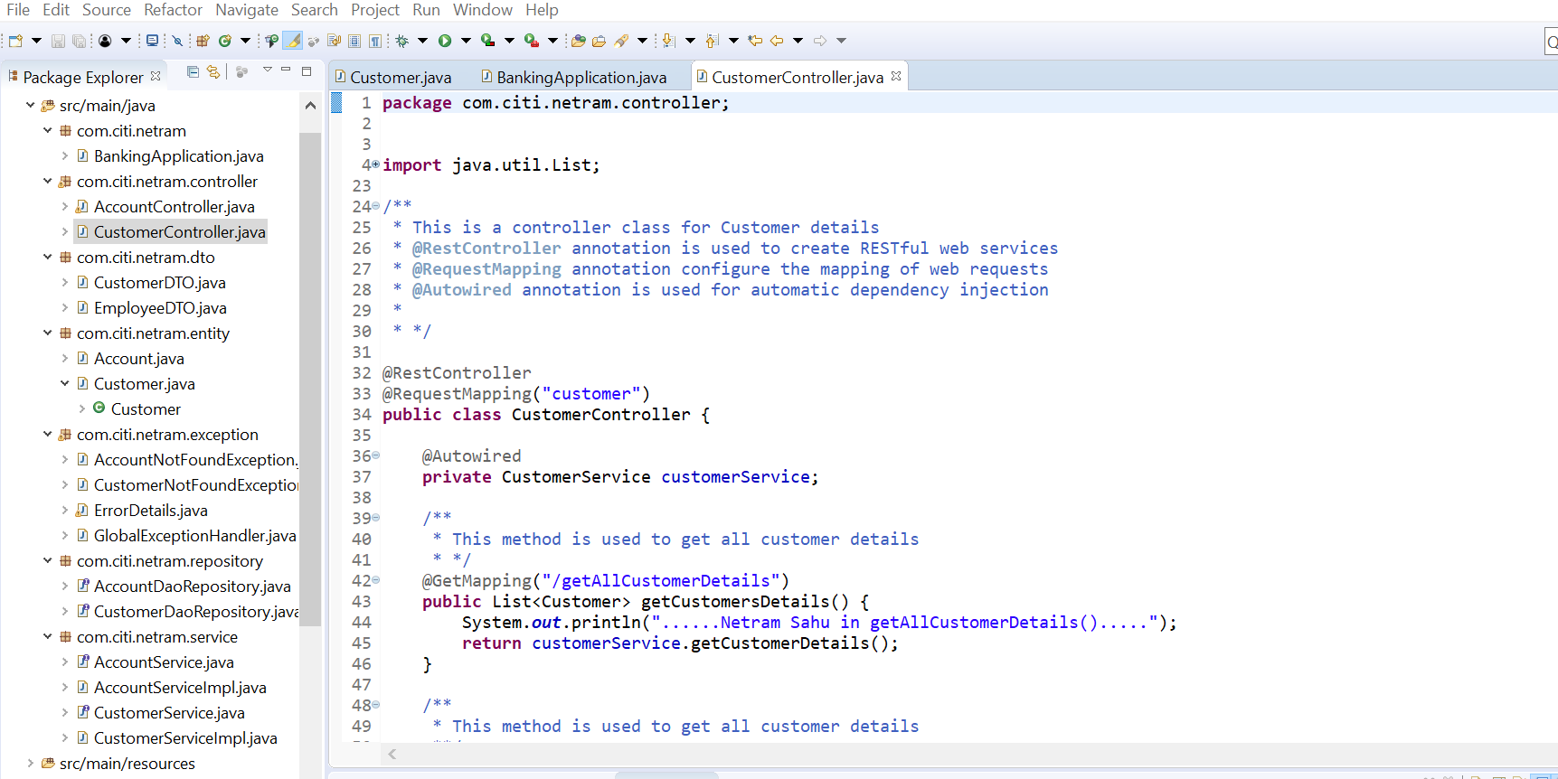

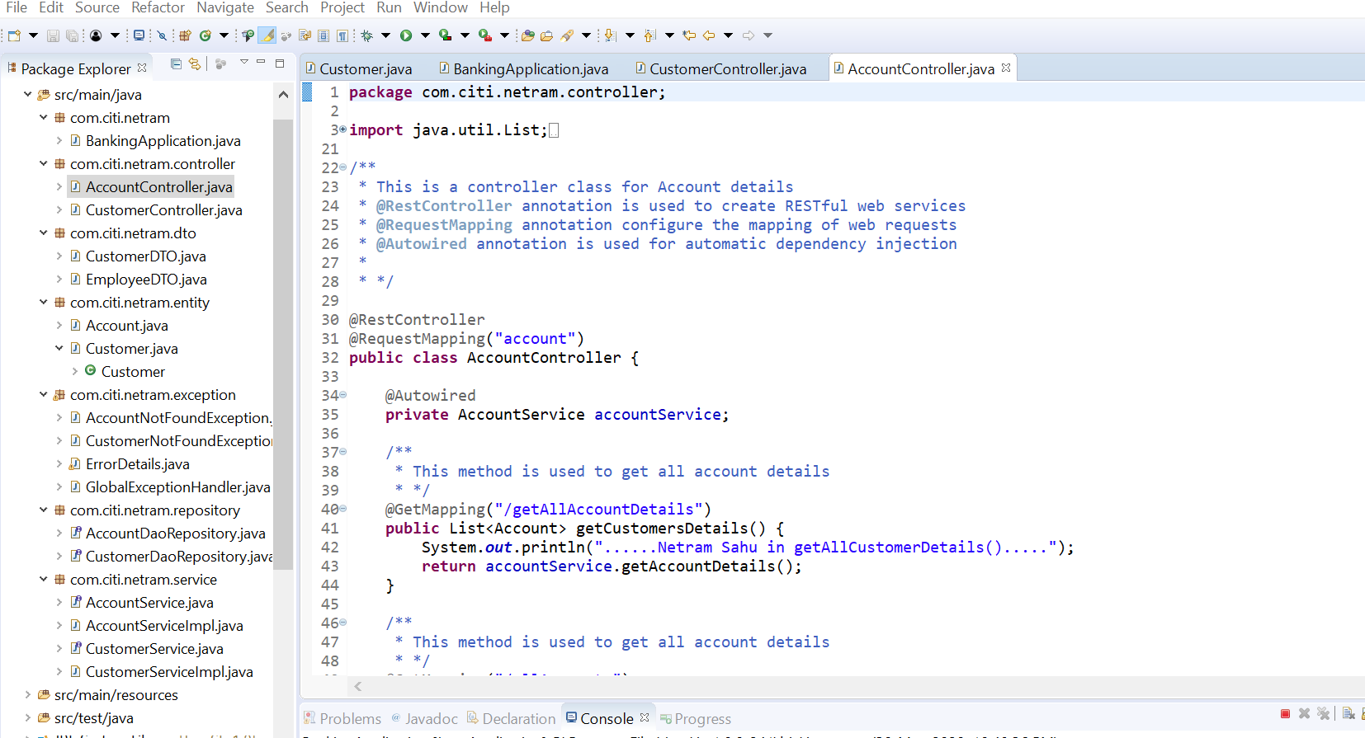

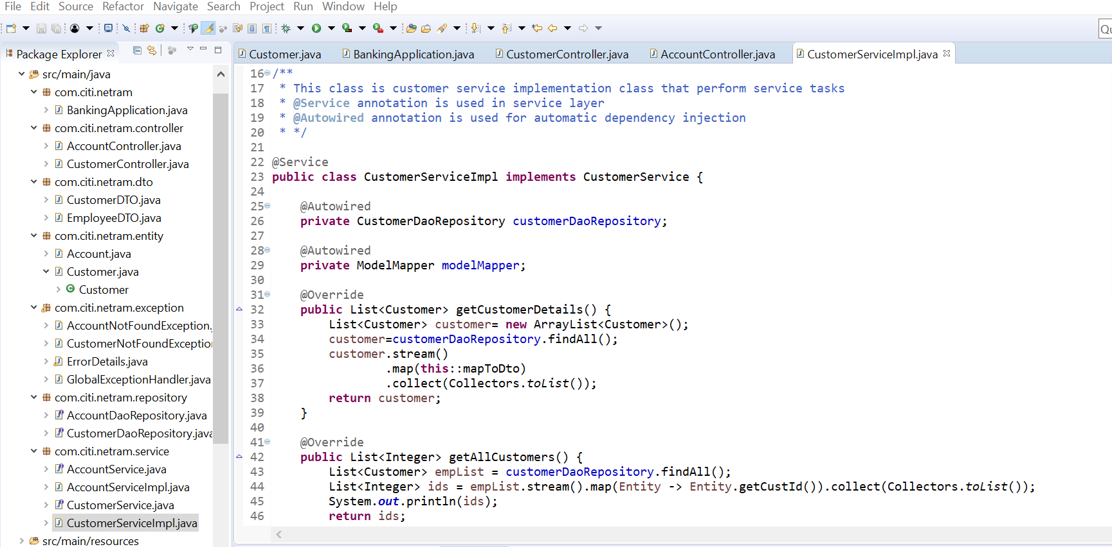

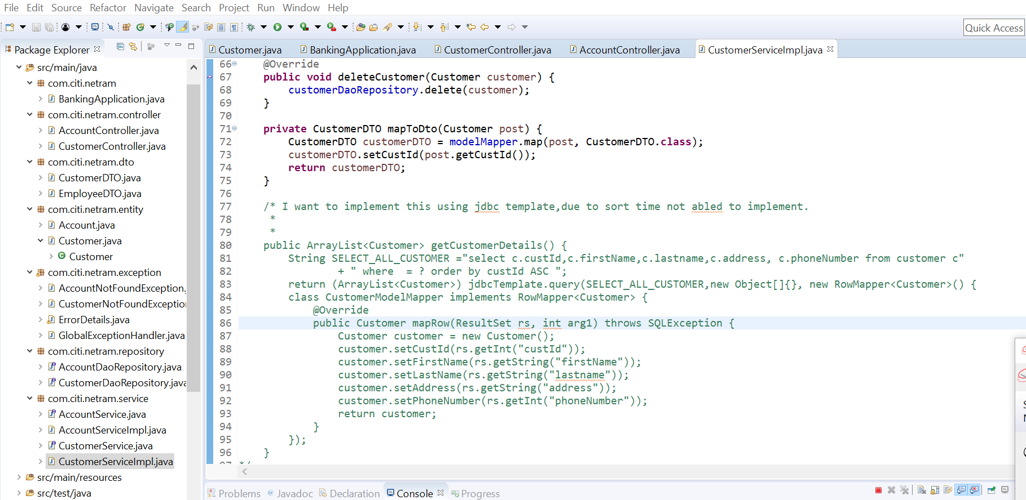

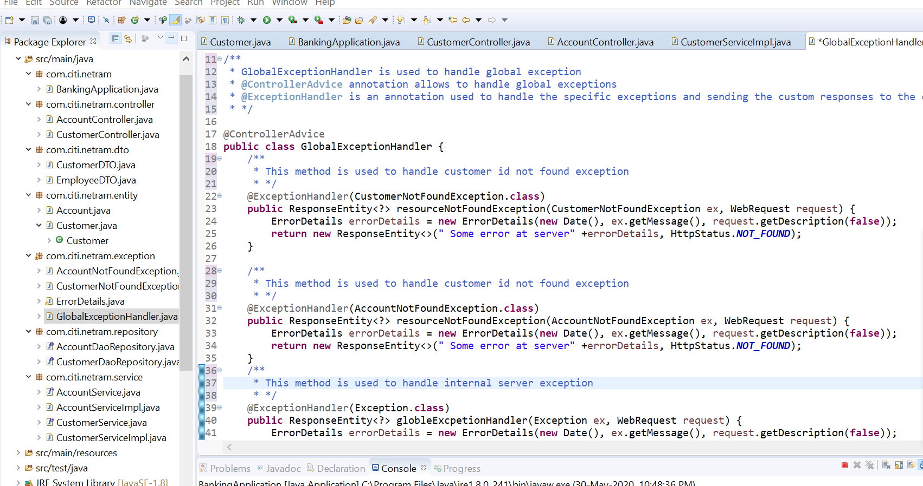

**Get All Customer Details:**

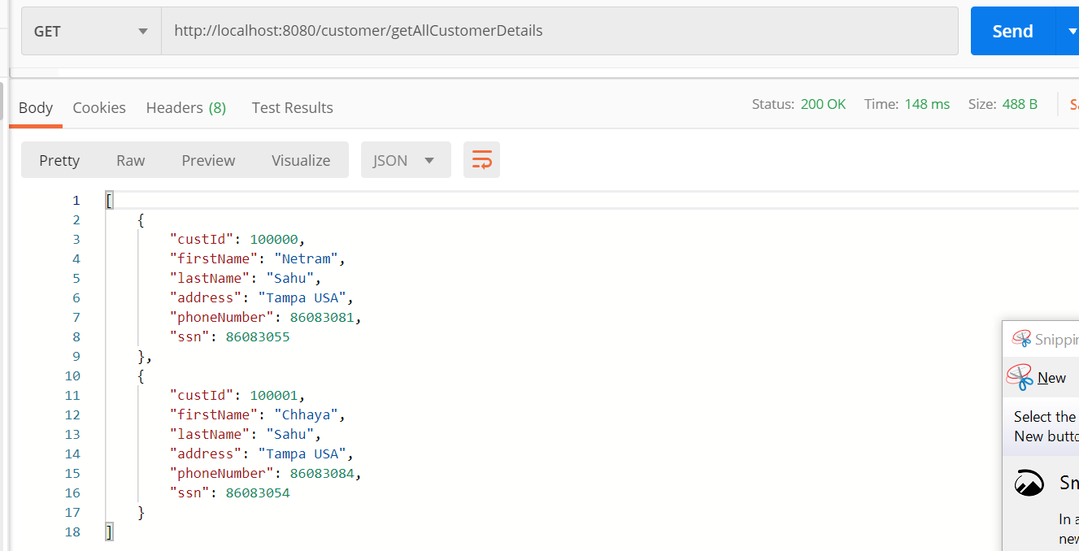

**Get Customer by customer Id**

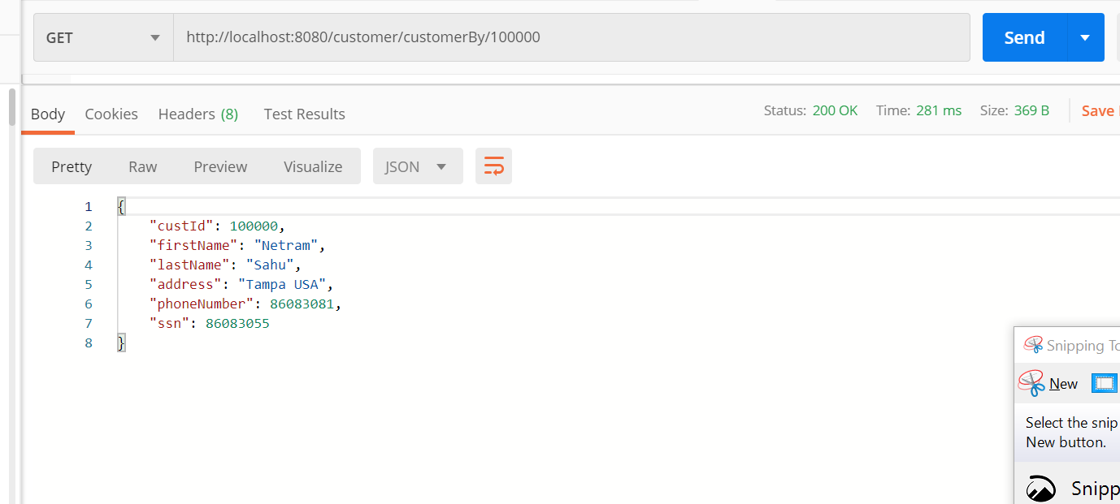

**Added New Customer**

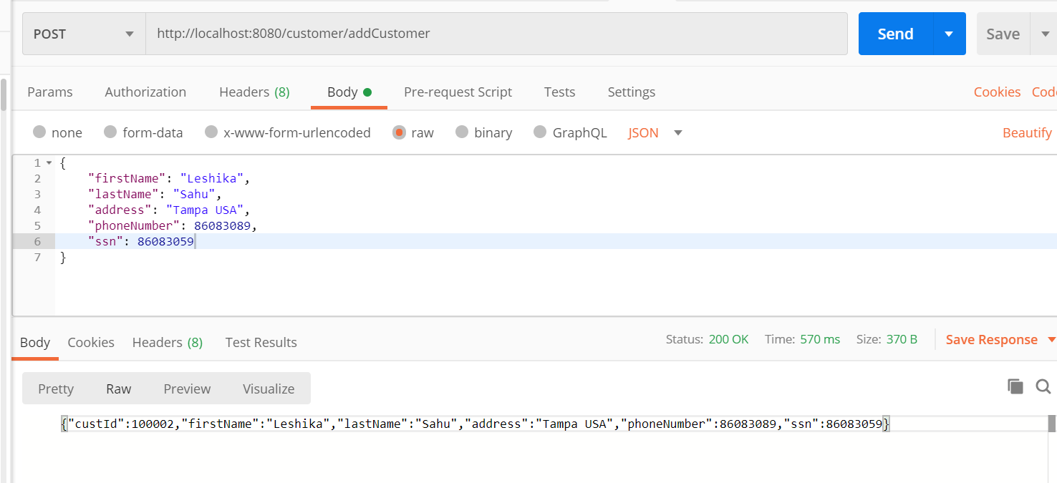

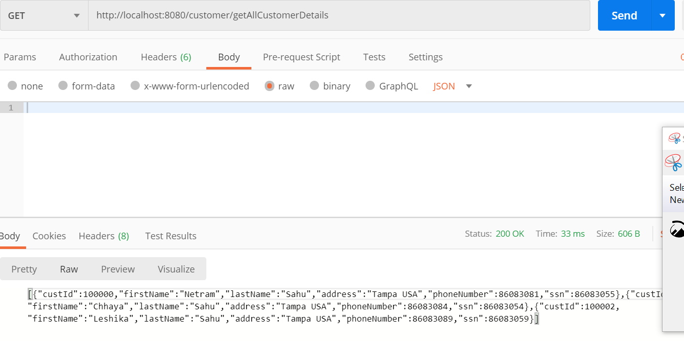

**Update Customer with address and SSN**

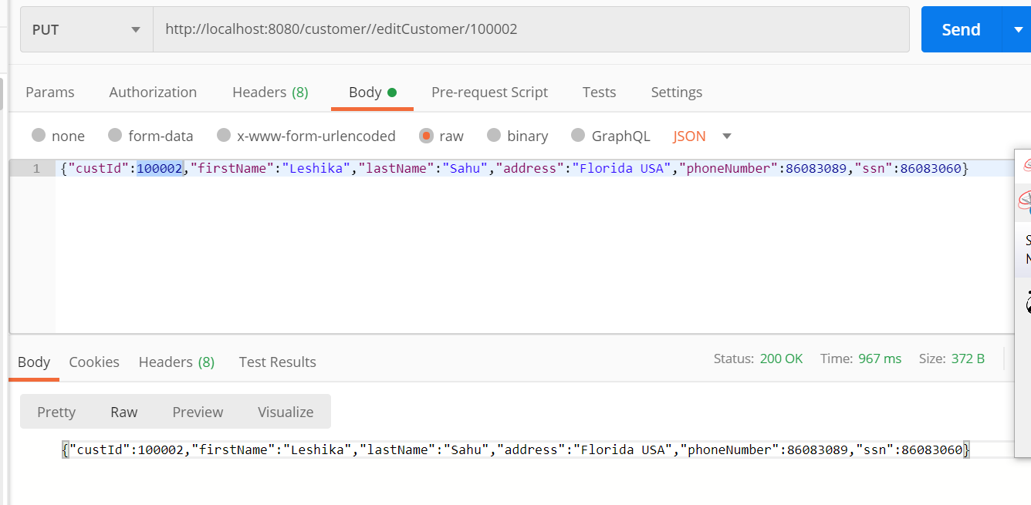

**Delete Customer Record**

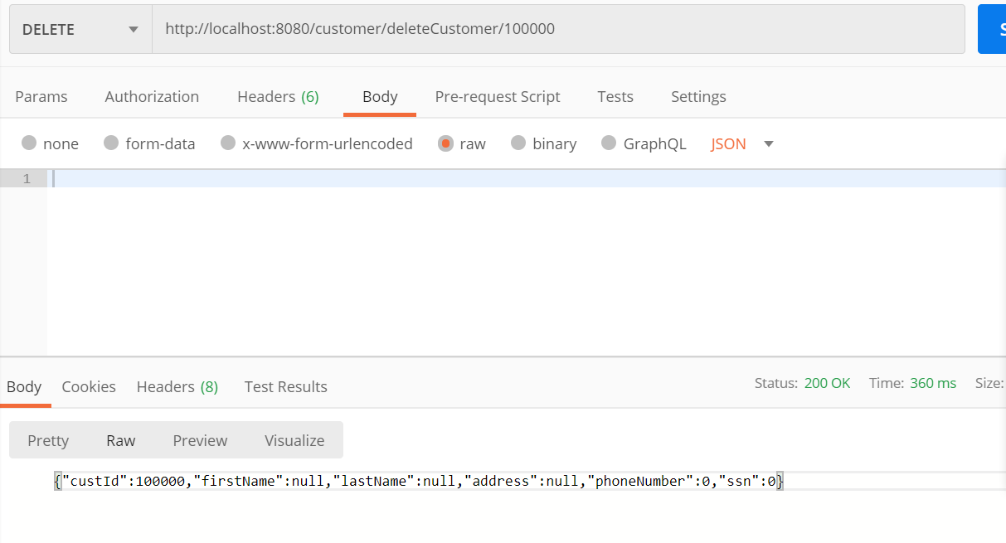

**Get Account Transaction Details**

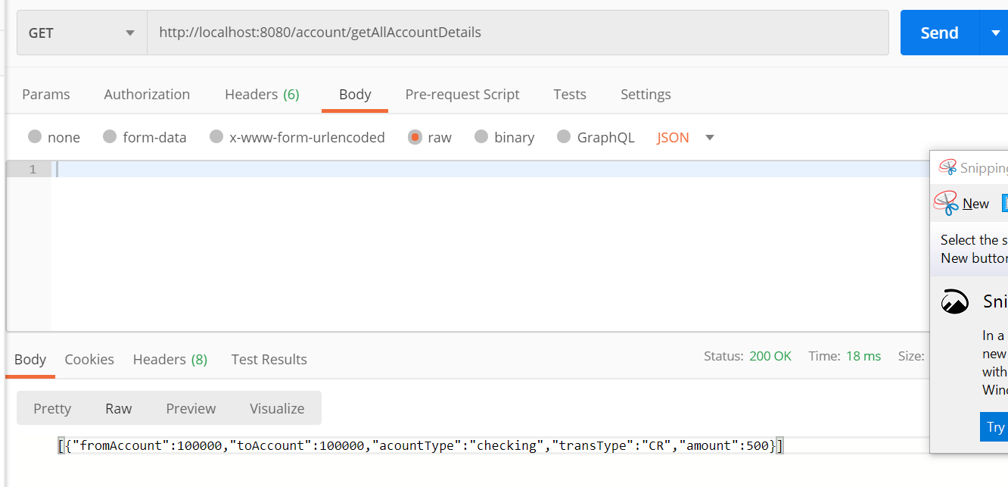

**Get account transaction by Account ID**

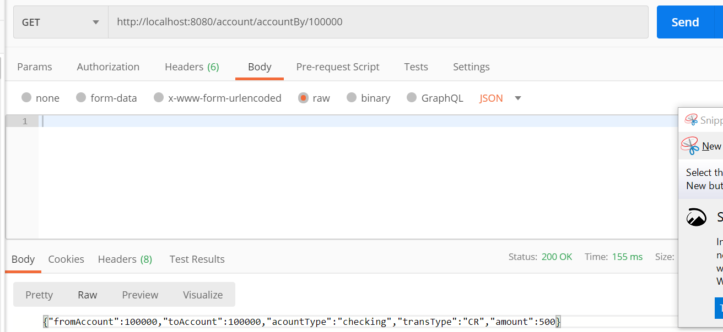

**Add new Transaction**

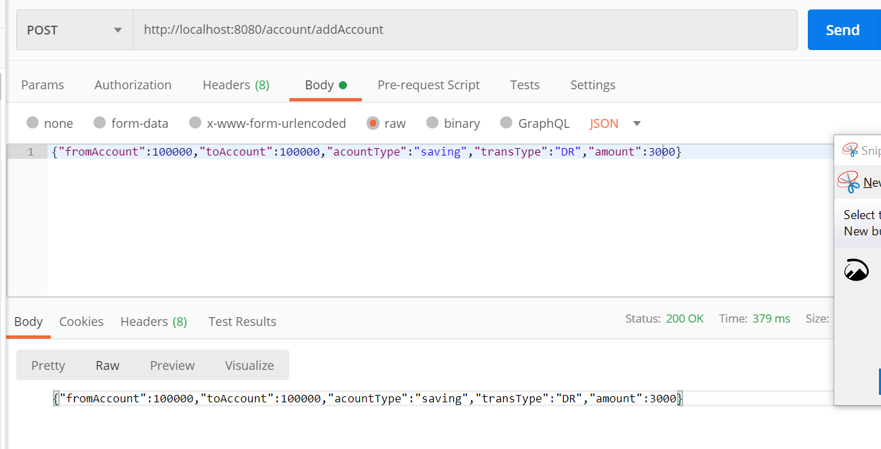

**Edit Transaction**

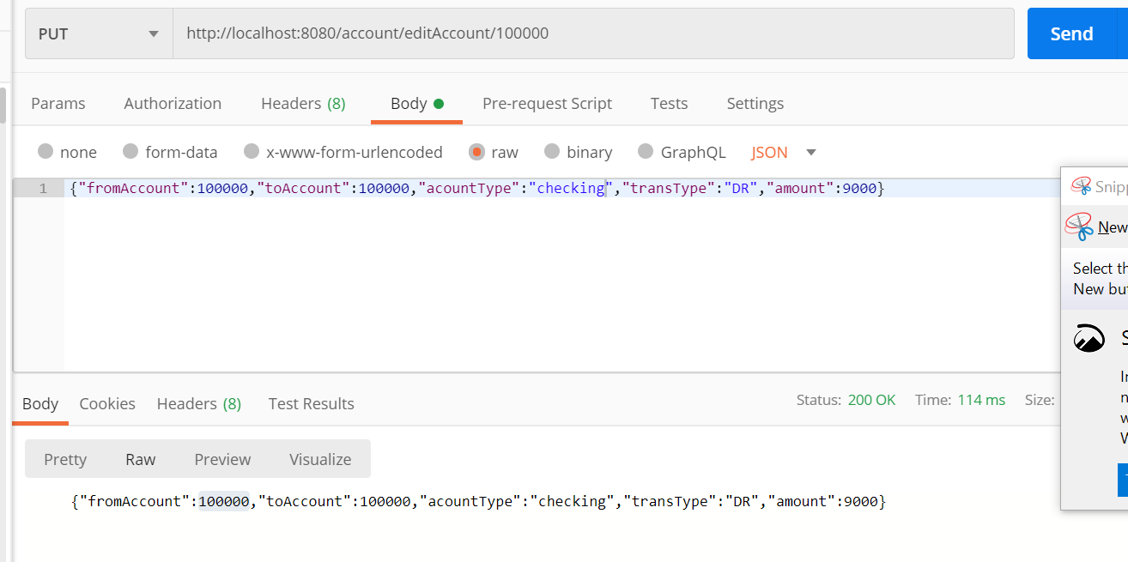

**Delete Transaction**

